Job Search Guide for Bon Secours Mercy Health
Bon Secours Memorial College of Nursing

You may qualify for some jobs even early in your nursing studies. There is a lot of competition for all jobs so students may need to apply for more than one vacancy. Please contact the Career Counselor at the College for assistance at Allison_Peterson@bshsi.org
Visit careers.bonsecours.com

Follow the screen captures below to locate student nurse jobs in central Virginia.
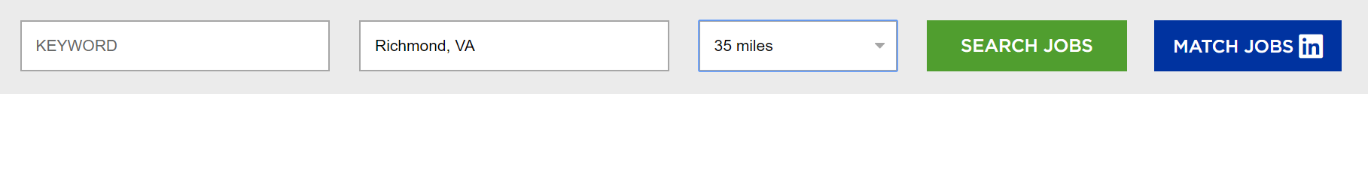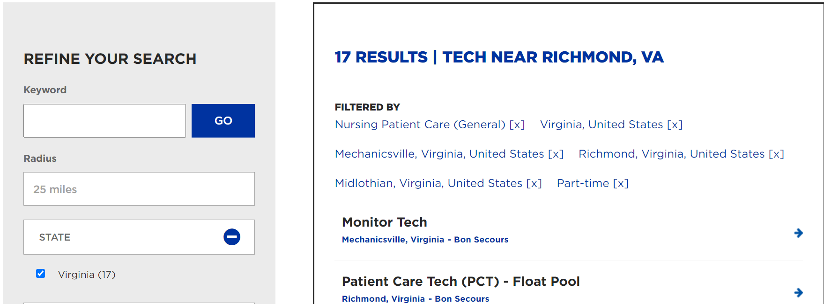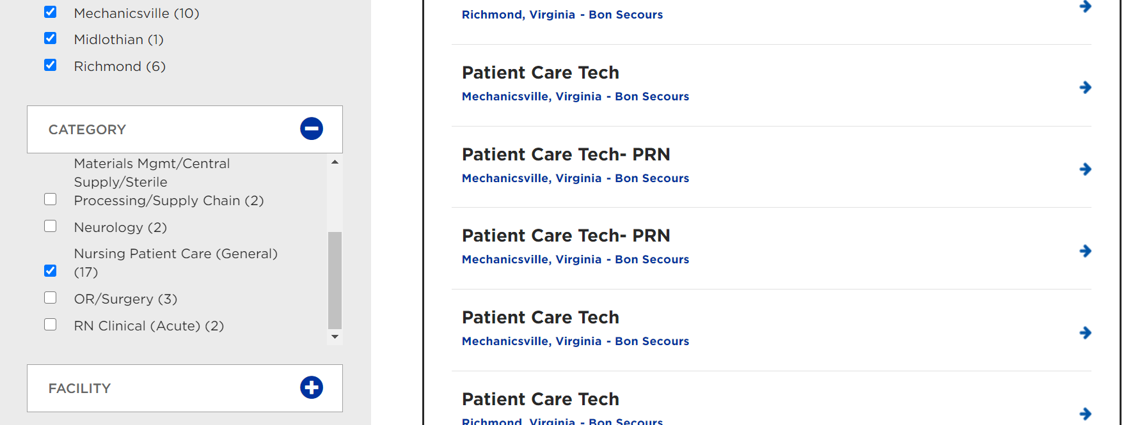

Sample Job Posting: PRN jobs are recommended for students. PRN should appear next to the job title.
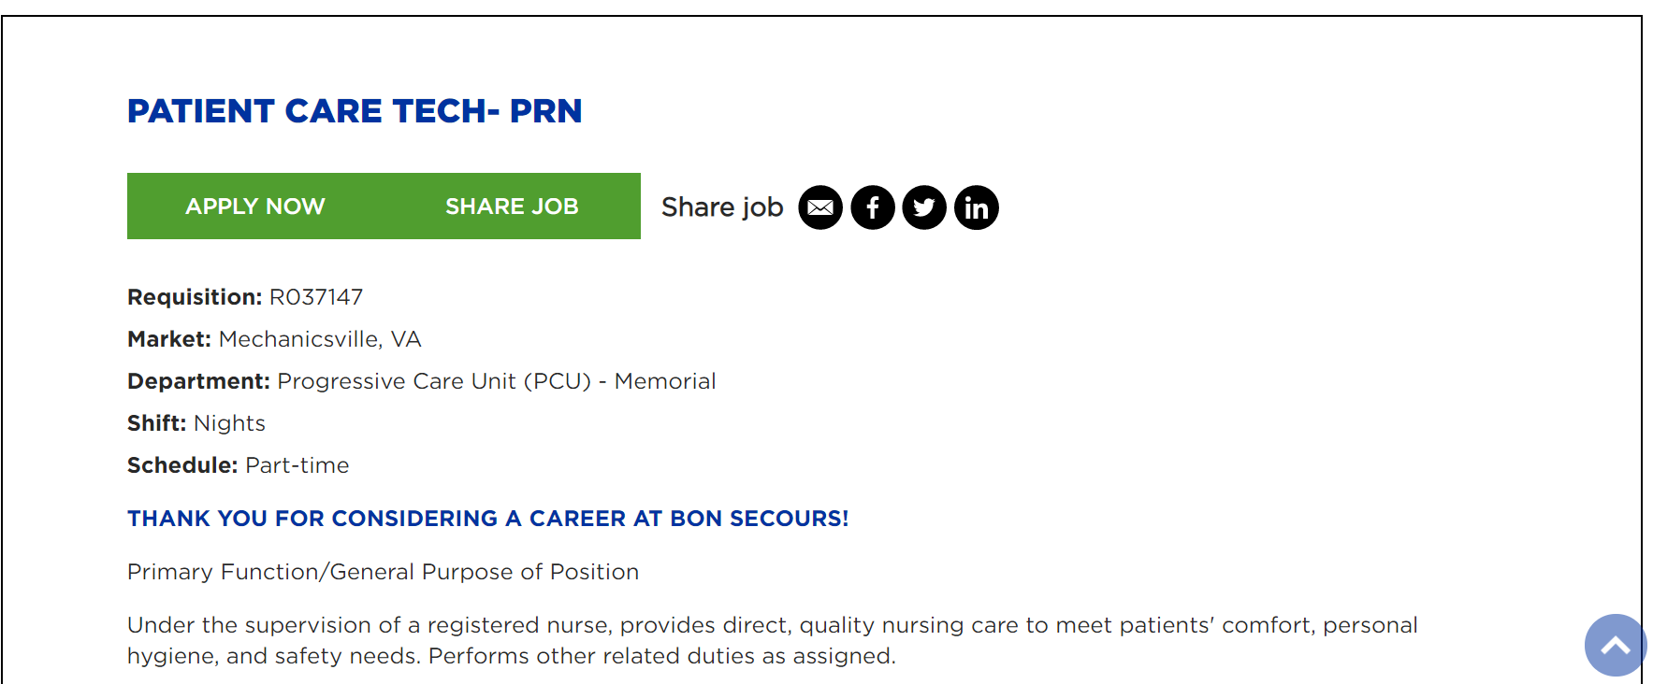
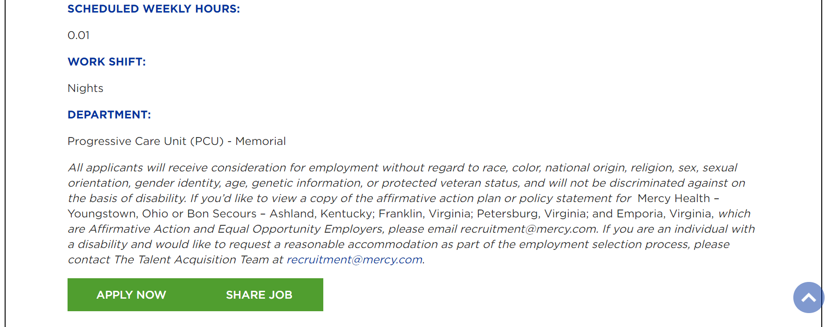
Which Jobs Do I Qualify For?
Possible student jobs include:
- Patient Care Associate
- Monitor Tech
- Unit Secretary
- Transporter

After completing NUR 2102 and 2103 or if you are a licensed C.N.A.:
- Patient Care Tech
- ER Tech
- Behavioral Health Tech
- Patient Sitter/Companion

Which Schedule or Shift Should I Select?
The recommended shift for a nursing student is PRN:
PRN requires a minimum of 24 hours per schedule (which is about 30 days). Most managers will allow you to work more hours when they have a need. Many units allow you to self-schedule your hours.

PRN = 24 hours monthly or more
Part-Time: = 20-31 hours weekly.
Full-Time: = 32-40 hours weekly.

To Apply
- Click on a specific job. Complete the entire application.
- Attach your resume saved as a PDF document
- If you get an immediate email indicating you will not be going forward in the
hiring process, it is likely due to high applicant volumes. Don’t be discouraged….just continue to apply.
- Send an email to Allison Peterson, the Career Counselor, and let her know that you have applied. She will alert Talent Acquisition (Human Resources) of your interest: Allison_Peterson@bshsi.org

Creating a Resume
- View some sample resumes at https://www.bsmcon.edu/resume-writing
- More free templates can be found in Word, Google Docs and Canva.
- Contact Career Services for assistance by emailing: Allison_Peterson@bshsi.org

Interviewing
- If you are invited to interview, check out the “Interviews Made Simple” guide for examples of the most common questions our students are asked! https://www.bsmcon.edu/index.php/interviewing

Orientation
- If hired, you will be required to attend New Employee Orientation, unit orientation, a health screening and certain types of training. Be aware that these are required and must be completed within certain time frames.
- Orientation and workplace training must not interfere with your classes/clinicals.
- Check your class schedule and if you need to, request on-line orientation at the time you accept the offer of employment. It is available certain times of the year.

CAREER SERVICES
Allison Peterson, Career Counselor, Bon Secours Memorial College of Nursing
Allison_Peterson@bshsi.org | (804) 627-5381 |
Careers.bonsecours.com
Student Jobs in the Bon Secours Mercy Health hospitals include:

Unit Secretary: the clerical staff member on the nursing unit. Tasks vary based on unit and include answering phones, alerting nurses of a patient/family member’s needs, ordering supplies, alerting housekeeping of a room vacancy, typing/data entry, paging physicians.

Patient Care Associate: working under the supervision of the RN, role varies by unit but may include helping patients with eating, dressing, toileting, answering call bells, alerting nurses of a patient/family member’s needs, and sitting with patients to insure their safety.

Must have completed sophomore studies for the following:
Patient Care Tech: working under the supervision of the RN, role varies by unit but includes helping patients with ADL’s (activities of daily living) including eating, dressing, toileting, ambulating. PCT’s also take vital signs, give bed baths, answer call bells, alert nurses of a patient/family member’s needs, interact with the multi-disciplinary healthcare team, contact physicians for consults at direction of the RN. Possibly administer IV’s and perform blood draws.

Behavioral Health Tech: same as Patient Care Tech but dedicated to the behavioral health unit at either St. Mary’s or Richmond Community Hospital.

ER Tech: Working in one of the Emergency Departments, the ER Tech may perform the duties of a Patient Care Tech (above) as well as routinely administering IVs, performing blood draws and assisting when a patient “codes” (May include cardiac and stroke intervention.) Phlebotomy skills preferred but may be acquired on the job. They work in a setting with above average levels of stress and heightened emotions characteristic of emergent medicine. Individuals who are certified EMT-B’s (Emergency Medical Tech Basic) or EMT-P’s (Paramedics) are in high demand.
These are generic job descriptions. Please ask about specific job duties during your interview.

