Approving Financial Aid
Campus Nexus Student www.bsmcon.edu/quicklinks >Student Portal - Campus Nexus Student

To review and approve pending Financial Aid navigate to My Financial Aid Tab >Award Letter.
Award Letters are separated by academic years, select “Review Award Details” for the academic year you wish to review.
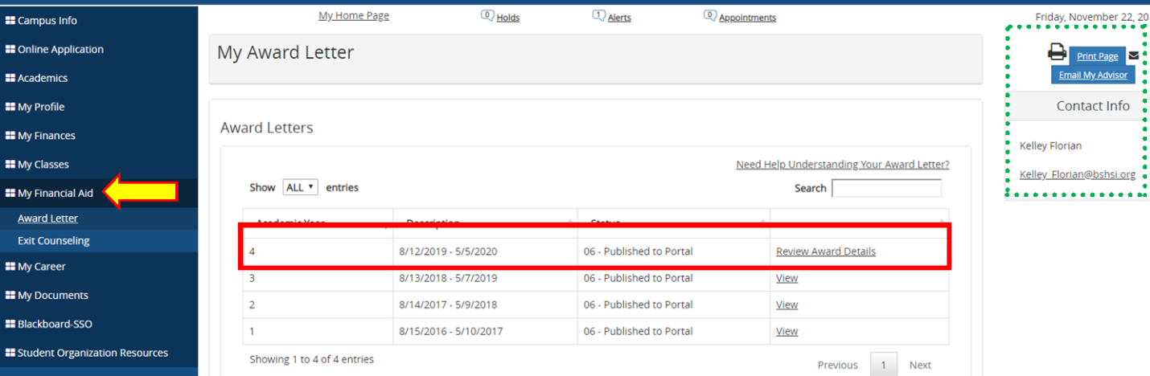
In the awards detail page you will need to accept and/or modify your awards.
PLEASE NOTE: Federal Grants will already be in Accept status.
Once all awards appear how you want, then select: ACCEPT All AWARDS.
