How to pay my bill
Campus Nexus Student www.bsmcon.edu/quicklinks >Student Portal - Campus Nexus Student

To pay your balance My Finances>Make a Payment Online.
Accept the payment agreement and select Continue.
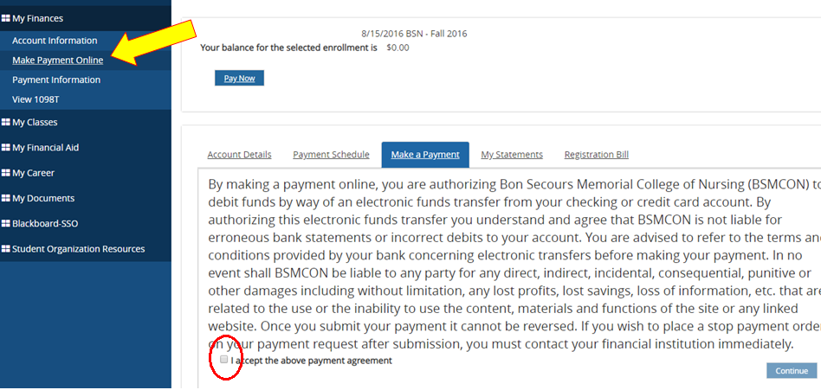
Online payment information will appear. Select or add a method of payment, enter the amount and hit PAY.
BOX 1: If you have saved credit card information in your portal can you can select that credit card
-Otherwise select “Add a Payment Method”
BOX 2. Enter your amount
BOX 3. Pay
