Reviewing your Registration Bill

Campus Nexus Student www.bsmcon.edu/quicklinks >Student Portal - Campus Nexus Student

Students must review registration bill each semester.

Access by Navigating to:
My Finances >Account Information >Registration Bill.

!! PLEASE NOTE: BOX A is the balance for your entire program, not the semester. You need to review the registration bill for each semester separately.

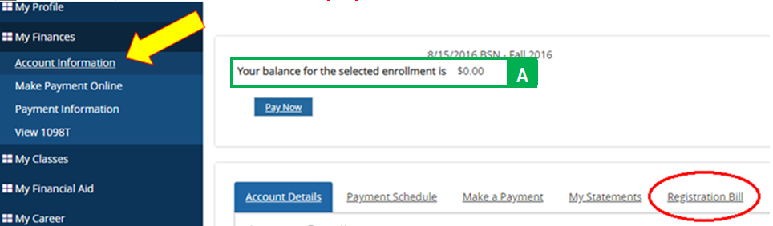
Select Registration Bill in the menu of options.

Registration Bill by Summary Term box will appear:
You need to indicate the Term From [BOX B] and To [BOX C] date for the semester specific registration bill.
FROM BOX: You can put in specific semester start date or if unknown simply select the first day of the month for the semester you are reviewing.
TO BOX: You can put in specific semester start date or if unknown simply select the last day of the month for the semester you are reviewing.

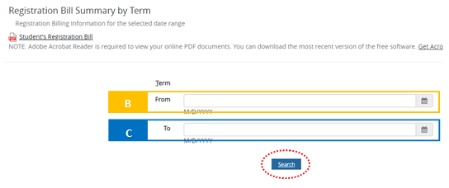

How to read the Registration Bill:
BOX 1: Amount due or (due to Student) = $0.00
This is the amount the student owed for the semester selected. If the amount is (in parenthesis) then the student can anticipate a refund in this amount. PLEASE NOTE: Refunds will not be processed until funds are received.

BOX 2: Account Summary
This is a summary of Box 3, 4 and 5

Box 3: CHARGES:
Tuition and Fees with Applicable Tuition Discounts for employees appear in this field

Box 4: FINANCIAL AID:
Only Approved Financial Aid will appear in this field. Once Approved this field will detail the Funding, Amount Scheduled and Scheduled Disbursement Date.
Review your financial aid award under: My Financial Aid Tab >Award Letter.
There is also a document provided be the Financial Aid Office titled “Approving Pending Financial Aid” for you to reference

Box 5: Payments
Any payment/s that has been received as of that date you review the bill will appear in this field. As financial aid funds are applied to your account they will move into this field of the registration bill, as is the case in the example.
