InfInformation & Technology

Two-Factor Authentication VPN

Provides information on how to log into the Bon Secours Mercy Health VPN client.
Once you enter your user name and password, you will be emailed and/or texted a one-time passcode to enter in the system to be able to gain access. Update your mobile number in the Outlook/Exchange Directory to receive txt message passcodes.

Logging In
- Log into Windows (you must be logged into Windows before you can connect to the VPN).
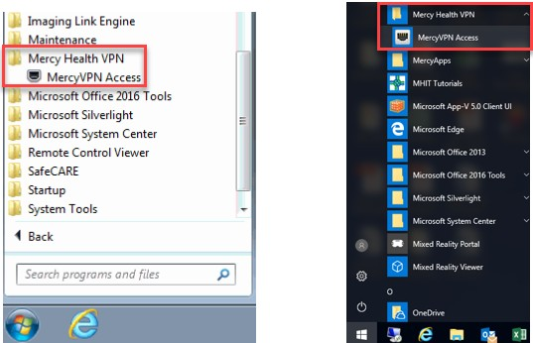
- Select Mercy Health VPN > MercyVPN Access from your list of programs. (Your screen will vary depending if you are using Windows 7 or Windows 10).
- Select the Connect button. The connection may initialize automatically.
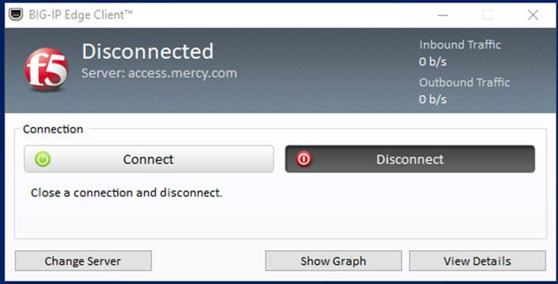

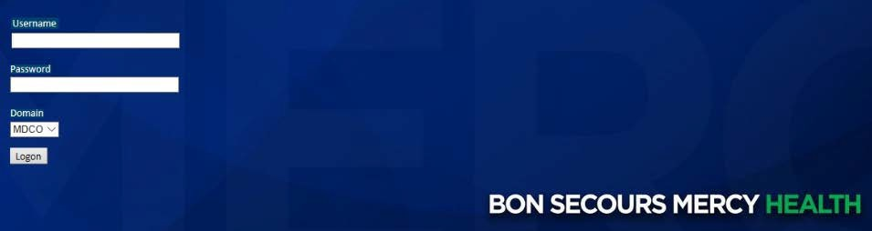
- Enter your network username and password. Select the Logon button.
- Select ADS in the domain drop-down.
MDCO. If you are in the Atlantic group, select ADS.
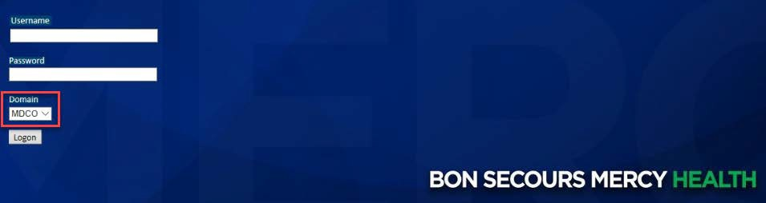
- Once you login with your username and password, the passcode will be sent to your e- mail address (and also to your mobile phone number if it is tied to your account).
- Clear any existing passcode and enter the 6-digit passcode and select the Logon button.
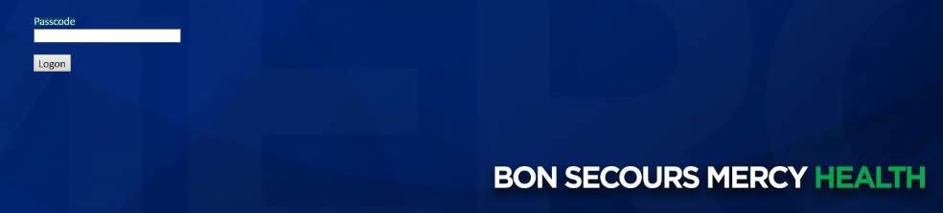

Information & Technology

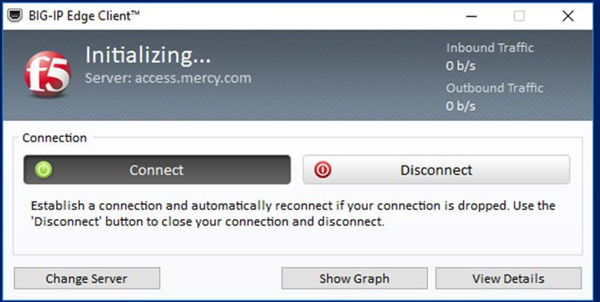
- As the connection is being established, you may notice a series of messages (Initializing, Authenticating, Finalizing.)
- You are now connected to VPN. (The F5 icon appears Red in the system tray when the VPN connection is active).
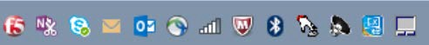

Logging Out
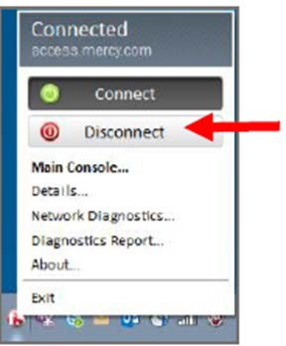
1. From the system tray, double-click the icon and select the Disconnect button

